Welcome to our School

Parent Handbook

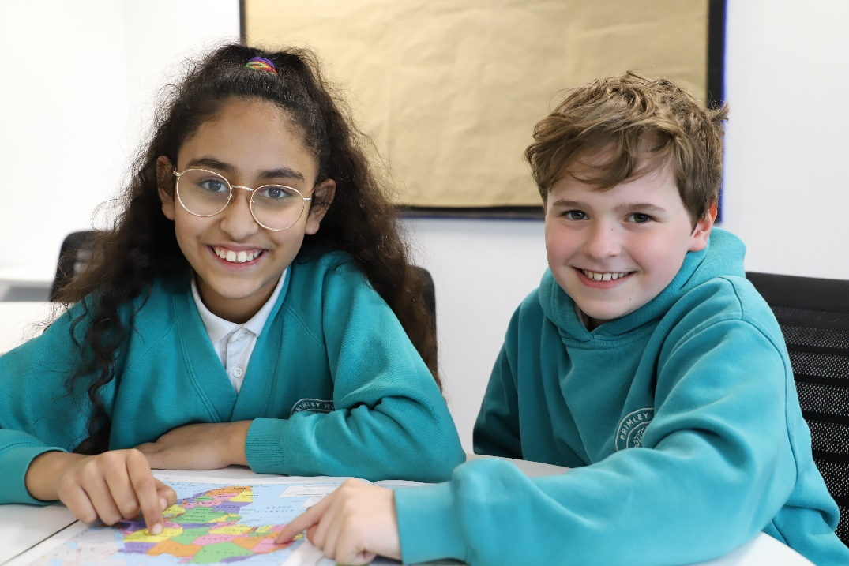

Fir Tree Rise, Alwoodley, Leeds, LS17 7EZ
Tel: 0113 887 3680
Email: info@primleywood.co.uk
Website: www.primleywood.co.uk
Welcome

Welcome to Primley Wood! We are so delighted that you have chosen our school and will be joining us soon. We have an excellent team who are dedicated to providing the best possible education for your child. We look forward to working with you and sharing the excitement of your child’s learning. In this handbook, you will find lots of useful information and the answers to some frequently asked questions. If you have any questions that are not answered, please contact the school office on 01138873680 and we will be happy to help!

Our school is committed to safeguarding and promoting the wellbeing of all children and expects our staff and volunteers to share this commitment.

Your Child’s Details

You will receive a copy of all our starting school forms via email. It is important that these documents are sent back to school fully completed before your child starts school. We will also need to see your child’s birth certificate and passport, which can be shown to our admin staff in the office.

School procedure

Timings of the school day

Time | Activity
7.45am to 8.50am | Breakfast Club (£4.00 per day per child)
9.00am | Morning Registration
12.00pm | Lunchtime
1.00pm | Afternoon Registration
3.30pm | Home Time
3.30pm to 4.25pm | Extra-Curricular Clubs (bookable half termly)
3.30pm to 6.00pm | After School Care (£8.00 per day per child)

Arriving to & departing from school

The school doors open at 8.50am to enable children to filter into school calmly, ready for a 9.00am start to the school day. Children, who arrive after 9.00am, will need to be brought through to the school office. If you need to collect your child earlier than 3.30pm, please inform the school office.

Key Information

Our Breakfast Club and After School Care can be booked in advance via Arbor (Our School app). We also accept last minute bookings up to 7.00 am on the day for breakfast club and up to 2.00 pm on the day for After School Care.
If you are in need of emergency wrap around care and have not been able to book in advance, please contact the school office team, who will be happy to help.

Attendance and Absence
Attendance is key for our pupils and we celebrate 100% attendance each week in assembly and at the end of each half term. Children are expected to attend every day unless they are ill.
Our attendance expectation is 96% and above.
Any absence should be rung through to the school office each morning the child is off.

Illness
When children have been off school with sickness or diarrhoea. Parents are requested to keep them at home for 48 hours following the last episode.

Medical Appointments
Medical and Dental appointments should be made outside of school hours where possible. If this is not possible, please bring proof of the appointment (i.e. letter from clinic) to the main office when you take your child out of school early.

Medicine in school
If your child requires regular, long-term medication such as an inhaler for asthma, then this should be discussed with the teacher and the school office. Any inhalers brought into school for use should be clearly labelled with the child's name and dosage requirements. There may be other occasions when your child needs to take medication for a short period of time but is well enough to come to school. In these instances, you should contact us to discuss your child's needs. All relevant forms are
available from the main office.

Term Dates
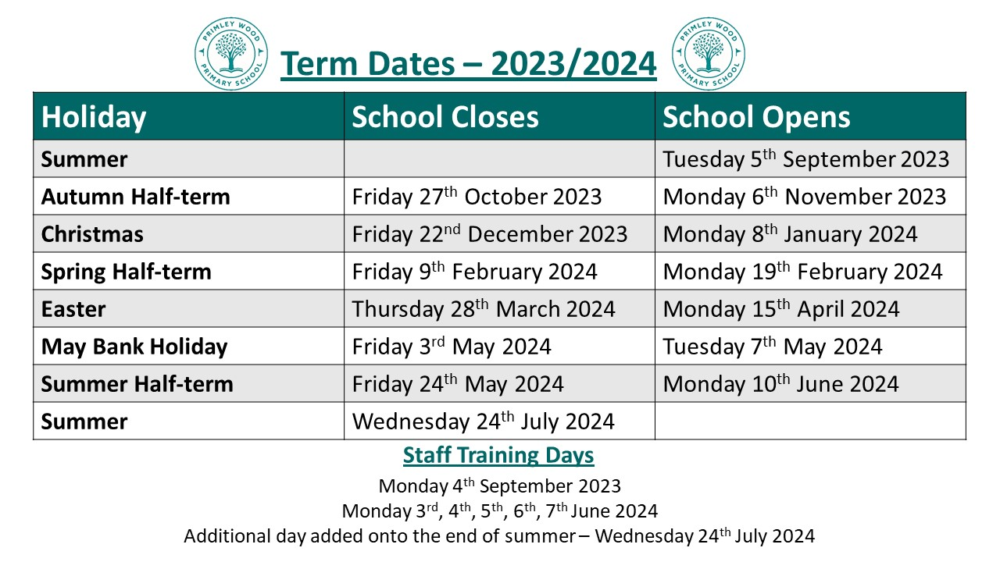

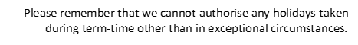
Our Uniform

All children in Years Reception up to Year 6 are expected to wear school uniform. This comprises of a white polo shirt under a jade sweatshirt or a cardigan along with grey trousers, skirt or pinafore. In summer grey shorts or green checked summer dresses are permitted. Branded uniform can be purchased from www.uniwears.co.uk or from the Uniform Shop at 18-20 Green Road, Leeds, LS6 4JP and unbranded from most high street shops and supermarkets.
PE Kits
Reception children do not require a PE kit but will require a full set of waterproofs and a pair of wellies so that they can access their Forest School curriculum every week. There is no specific colour requirement for these items so can be bought from any high street shop or online.

All children from Year 1 to Year 6 do require a PE kit. This kit comprises of a white T-shirt, plain navy shorts or jogging bottoms and footwear suitable for indoor and outdoor sports. This kit should be brought into school in a drawstring bag or similar.

Other items
All children should bring a book bag with them so that letters and reading books can be easily transported between home and school. Branded book bags can also be purchased from the Uniwears shop.
All children should bring a named water bottle with them to keep them hydrated during the school day.
Children not having school meals will also need a suitable bag to carry their packed lunch in.

School Meals

Our Vegetarian school meals are cooked fresh in our wonderful kitchen by fantastic staff from the Leeds City Council Catering Team. The menus run on a 3-week cycle and are available to view on our website. The children have a choice of three different meals each day which they can choose from during registration each morning.

For children in KS2, school meals are payable online via Arbor at a cost of £2.50 per day.
All children in Reception and Years 1&2 are eligible for a meal through the government's Universal Infant Free Schools Meal.
From Year 3 upwards some children whose families meet the criteria for benefits may be entitled to free school meals. If you think your child may be eligible, please ask at the office for details on how to apply.

Children who have specific dietary requirements can be catered for providing that the
relevant documentation has been completed. If your child requires a special diet, please contact the school office for more information.

School Milk

School milk is free for children up until the beginning of the term in which they turn 5.
For children aged 5 and over who would like to have milk at school, this can be ordered and paid for via the Fresh Pastures website.
Please visit the Fresh Pastures website to register and set up at www.freshpastures.co.uk/parents
Key APPs

Class Dojo is used by the whole school community. It is a fantastic APP that allows parents to view what is happening at both a class and a whole school level. Within the APP is a message function so that parents can contact staff directly with any queries rather than having to ring through to the school office. Class Dojo may also be used from time to time to set homework and to share photographs of what your child has been doing in class.

This App is used by the families of Nursery and Reception children only. Through this App parents can view their child’s learning journey and progress. Parents are also welcome to add comments and photographs about their child’s learning at home.

This is our online payment service for dinner money, music lessons, Breakfast and After School Care Club fees and school trips. You are able to link your children to a single account with ease and it gives you the freedom to make payments to school whenever and wherever you like.

Home Learning APPs
Numbots is an App we use throughout all classes, by equipping children with a platform like NumBots – which makes it easy and enjoyable to do maths at home – even homework averse families should keep on track with regular maths practice.

BoomReader is designed to make logging reading quick and easy whilst providing schools with the reading insights they need.
By swapping to digital reading records, you are helping your child’s school to gain a better understanding of reading and save hours of valuable teacher time.
With BoomReader teachers have instant, searchable access to reading data which can help improve reading outcomes.
Spelling Shed provides parents:
-A game-like format that helps builds your child’s confidence in spelling
-The ability for children to create their own weekly word lists
-A full spelling curriculum that is grade level specific and provides weekly online and offline activities
-Phonics based lists for your early learners
-The ability to track your child’s progress and see what words they are frequently misspelling
Website

Our website is designed to offer a user-friendly experience, providing easy access to a wide range of content and features. Whether you are looking to learn more about our school, explore our resources, or connect with our school, we aim to make your experience as enjoyable as possible.
On Our website http://primleywood.co.uk/ you will be able to find our policies, curriculum, community support links, newsletters and more.

Parental Involvement

Here at Primley Wood we actively promote partnerships with parents and all members of our school community, and your views and opinions really matter to us. Each term, every year group provides parents with curriculum newsletter to raise awareness of the topics that the children will be covering.

Parents and carers are encouraged to speak to the class teacher about any concerns they have at the earliest opportunity either in person or via the Class Dojo APP.
There are two Parent’s Evenings held each year where parents are invited in to speak to class teachers to discuss their child’s progress.

We provide lots of opportunities to invite parents into school, like assemblies, seasonal and cultural celebrations and sports day. We really believe in a two-way partnership.

Our PTA

Our PTA (Parent Teacher Association) are an incredibly active group within our school community. They work hard to support the school through organising key fundraising events throughout the year. The PTA are always looking for new members and would welcome any new parents to enhance their team.
If you would like to find out more about the PTA, or are looking to become a member, please contact the school office to find out more.

School clubs

Participating in extracurricular clubs is a fantastic way for students to explore their interests, develop new skills, and build friendships outside of the regular academic curriculum. We encourage you to consider these clubs as a means of enriching your child's primary school experience.

Some of the clubs available may include sports clubs, academic clubs, arts and culture clubs, community service clubs, leadership clubs, and hobby/special interest clubs. The specific clubs offered may vary from year to year based on student interest and availability.

Here are some After-School and Extra-curricular club examples below:
Drama Club | Guitar Lessons | Social Lego Club | Cricket Club
Arts & Crafts | Football Club | Choir Club | Judo Club
Chess Club | Multi-Sports Club | YouTube 101 Club | Cheer Leading Club
Thank you

We would like to thank you for choosing Primley Wood Primary School.

Our primary school is dedicated to providing a nurturing and stimulating learning environment that promotes the academic, social, emotional, and physical development of each student. We strive to create a positive and inclusive atmosphere where children feel valued, respected, and supported in their individual needs and goals.
We believe that education is a partnership between the school, the family, and the community, and we welcome your involvement in your child's learning journey. We look forward to working together to help your child reach their full potential and achieve their goals.
Thank you again for choosing our primary school. We are excited to have your child as part of our school community and look forward to a successful and rewarding educational journey.

Contact Us

Primley Wood Primary School
Fir Tree Rise
Alwoodley
Leeds
LS17 7EZ

0113 8873680
www.primleywood.co.uk
info@primleywood.co.uk

We look forward to seeing you start your journey with us

