Starting Reception in 2023

Starting Reception can be an exciting but daunting prospect for both children and families, but we hope that as soon as you set foot inside our warm and welcoming environment you will soon feel right at home.
This booklet has been designed to answer some of the questions you may have about our school.
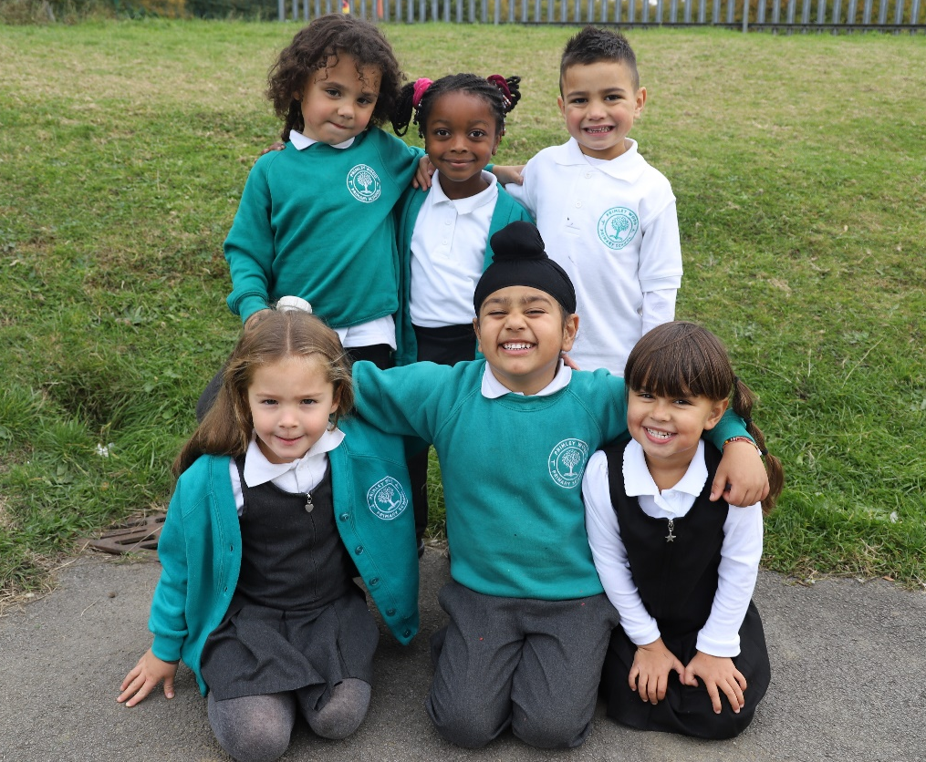

Fir Tree Rise, Alwoodley, Leeds, LS17 7EZ
Tel: 0113 887 3680
Email: info@primleywood.co.uk
Website: www.primleywood.co.uk
About our School

Founded in 2013, we are a friendly, family-orientated and inclusive free school in Alwoodley. We are a single form entry school with an abundance of space both indoors and outside.

Our school is made up of a community; from the children and staff to their families and all those people we work with every day. Everyone is valued and everyone plays their part. We work hard to ensure that our children will eventually leave us with a wider understanding of the world, their part in it and how they can live happy fulfilling lives.

Together we make up a family in which everyone is welcome.
This is supported by our school motto:

See the Light in All.

The start of a seven-year journey

So how does that transfer to the day-to-day school environment?
We are often told that our school ‘feels’ different: as soon as you enter the building it feels welcoming, calm and comfortable. Every child is recognised for their individual talents and supported to bring out the best in them.

Where can I read the Ofsted report?
We were very proud when Ofsted judged us as ‘Good’ in December 2019, and as we love a challenge, we are now starting our journey towards becoming ‘Outstanding’. There is a link to our Ofsted report on the website home page.
As we all embark on the seven-year journey of your child’s primary education, we wish you all a very warm welcome and want you to know that we are here to help whenever we can.

We want everyone who joins us to become part of our school family. We’re going to be supporting each other for the first seven years of your child’s education so it’s important that we all have a good relationship, know what’s expected of us all and where to turn for help.

If this is your first child to start school, then never mind the next seven years, what does the first week look like?

Children will be invited to a series of ‘Stay and Play’ sessions in school to get them familiarised with their new surroundings and to meet the staff and children who they will spending their days with in school. We will keep you posted about prospective days for these sessions closer to the time.

On the First day - Morning only
A nice easy morning of playing in the Reception Classroom and outdoor area to get us all started. Children are dropped off and collected from the classroom before lunch.

On the Second day - Stay for lunch
As well as coming in for a morning session, the children stay for their first lunch in the dining hall! A quick visit to the playground and they’re picked up early afternoon.

The rest of the week - Business as usual
We like to get into the swing of the school day as soon as possible so the rest of the week we stick to the usual school routine: drop off by 8.50am and pick up at 3.30pm. Breakfast Club and after school care are also available from their first week onwards.

Building key relationships in a nurturing environment

Our Curriculum
We are very proud of our curriculum. We follow the children’s interests and key calendar events to make sure planned activities are relevant and interesting, whilst also making sure key skills are addressed to ensure the children have a strong foundation on which to build as they continue to grow and learn.

During a typical school day, children will have short bursts of directed teaching time where they will learn key aspects of mathematics, literacy and phonics. In between this, they spend a sustained time exploring carefully planned areas of provision. Within these areas they are given opportunities to explore, practise and extend their learning. It is during this time when teachers will develop strong relationships, model social skills and develop language and communication skills. They will also find out about an individual child’s interests, needs and next steps in learning. This allows for a very personalised curriculum for all our pupils.
Phonics is an integral part of our curriculum in the EYFS, we use a systematic synthetic approach to teaching the sounds of the English language. Children receive daily phonics input where they will learn new phonemes and have the opportunity to practise using them in reading and writing activities. Children are provided with high quality decodable texts that they take home to enjoy practising their reading skills with their families.
Literacy is taught through high quality texts. Stories are carefully chosen to ignite imagination and curiosity but also allow for key elements of the English language to be taught. Staff will model writing and create opportunities for storytelling and writing for a purpose.

We follow both the mastery approach to mathematics outlined by the White Rose Maths Hub and the Mastering Number program from the NCETM. This scheme allows children to learn key mathematical concepts and use concrete resources to deepen their understanding of numbers.

What and how do we learn in Reception?

The Early Years Foundation Stage (EYFS)

The Early Years Foundation Stage curriculum is delivered through carefully planned activities and play opportunities to help ensure that all children have the opportunity to reach their full potential and experience the best possible start to their education. The EYFS sets out seven ‘Areas of Learning and Development’ and together these make up the skills, knowledge and experiences appropriate for children as they grow, learn and develop. They are:
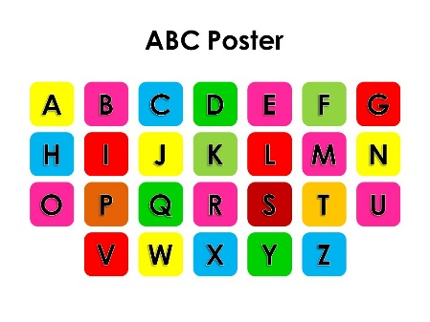
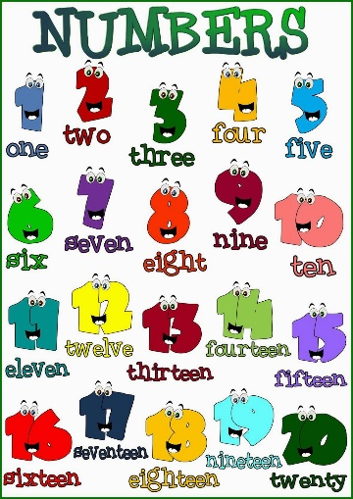
Prime Areas (support development in other areas)
- Communication and Language
- Physical Development
- Personal, social and emotional development

Specific Areas (essential skills and knowledge)
- Literacy
- Mathematics
- Understanding the World
- Expressive Arts and Design

Curriculum
- Autumn Term – All About Me, Celebrations
- Spring Term – Safe Shelters, Terrific Transport
- Summer Term – Powerful Plants, Amazing Animals
- More details about the curriculum can be found on our Website.
- We also post regular newsletters to explain the learning for the Half-Term.

How will I know what my child is learning,
And how can I support them?

We use ParentZone (an online learning journal) throughout Nursery and on into Reception to document key moments in a child’s learning and development. Parents have access to this online portal and can view their child’s learning journal at any time.

The wonderful thing about ParentZone is that parents can also contribute to the learning journal by adding their own comments and photographs of events and learning that has taken place at home.

Class Dojo is used by the whole school community. It is a fantastic APP that allows parents to view what is happening at both a class and a whole school level. Within the APP is a message function so that parents can contact staff directly with any queries rather than having to ring through to the school office. Class Dojo may also be used from time to time to set homework and to share photographs of what your child has been doing in class.
Also keep an eye on ClassDojo for general updates on what the class has been doing & any messages throughout the day.

You can also check out our website for our class curriculum, which will be updated regularly.
We will be sharing things such as Half-termly newsletters and school trips permission forms and more.

We offer a number of parenting workshops at Primley Wood which we like as many parents to be involved with as possible.
Some of the workshops include:

- Phonics workshop
- Mastery Number Workshops
- Stories, Songs & Rhymes

Home Learning APPs

Numbots is an App we use throughout all classes, by equipping children with a platform like NumBots – which makes it easy and enjoyable to do maths at home – even homework averse families should keep on track with regular maths practice.

BoomReader is designed to make logging reading quick and easy whilst providing schools with the reading insights they need.
By swapping to digital reading records, you are helping your child’s school to gain a better understanding of reading and save hours of valuable teacher time.
With BoomReader teachers have instant, searchable access to reading data which can help improve reading outcomes.

Forest School

A Forest on our doorstep!
Every week, come rain or shine, the children have the opportunity to spend a full morning exploring the forest. We see such a huge amount of personal development take place when the children are outdoors. They learn team building skills, develop physically, gain confidence and find out about the natural world. Children will require a full set of waterproofs and wellies to fully immerse themselves in Forest School life.
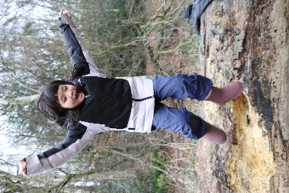
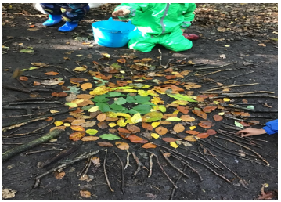

Moving to KS1

Our children cope very well with the transition into Year 1. The strong foundations of skills and knowledge learned during their time in reception is carefully built upon in a similar teaching style. The amount of direct teaching time is extended during the spring and summer terms and the staff will work with small groups of children on their key ‘next steps’ in a particular subject. As the year progresses, children will be expected to complete some work independently in order to build up resilience and their time spent in areas of provision may be reduced.

By the time our children leave Reception, they will have become confident and resilient learners who are more than ready to take on the challenges of Year 1. During our whole school transition days, the children will have chance to spend time in what will be their new classroom and will get to know their next teacher. This builds confidence and reassurance ready for the next step in their education.

Thank you

We would like to thank you for choosing Primley Wood Primary School.

Our primary school is dedicated to providing a nurturing and stimulating learning environment that promotes the academic, social, emotional, and physical development of each student. We strive to create a positive and inclusive atmosphere where children feel valued, respected, and supported in their individual needs and goals.
We believe that education is a partnership between the school, the family, and the community, and we welcome your involvement in your child's learning journey. We look forward to working together to help your child reach their full potential and achieve their goals.
Thank you again for choosing our primary school. We are excited to have your child as part of our school community and look forward to a successful and rewarding educational journey.
Contact Us
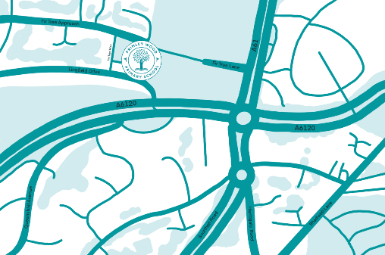
Primley Wood Primary School
Fir Tree Rise
Alwoodley
Leeds
LS17 7EZ
0113 8873680
www.primleywood.co.uk
info@primleywood.co.uk

