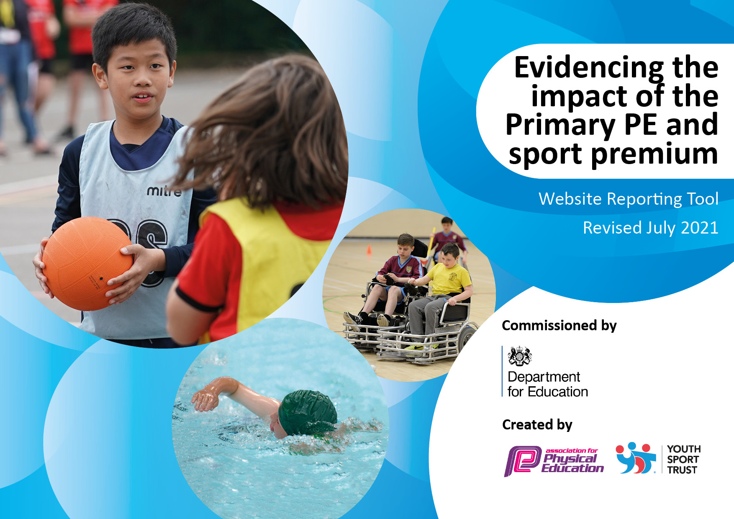
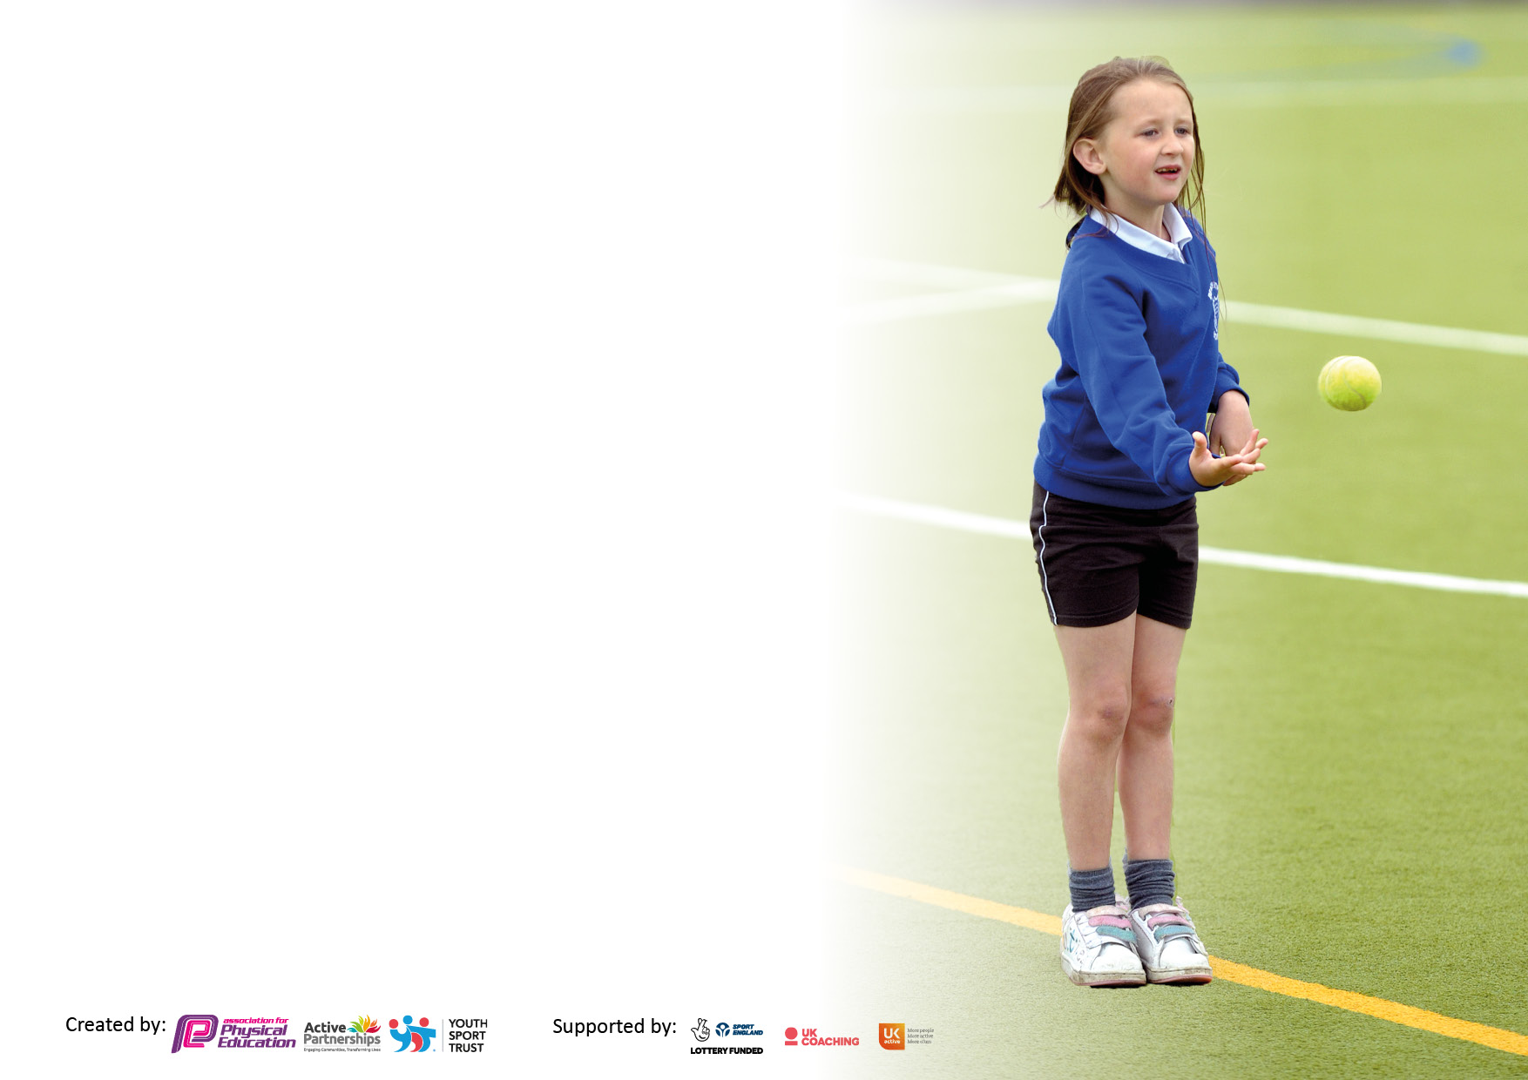

It is important that your grant is used effectively and based on school need. The Education Inspection Framework makes clear there will be a focus on ‘whether leaders and those responsible for governors all understand their respective roles and perform these in a way that enhances the effectiveness of the school’.

Under the Quality of Education Ofsted inspectors consider:
Intent - Curriculum design, coverage and appropriateness
Implementation - Curriculum delivery, Teaching (pedagogy) and Assessment
Impact - Attainment and progress

To assist schools with common transferable language this template has been developed to utilise the same three headings which should make your plans easily transferable between working documents.

Schools must use the funding to make additional and sustainable improvements to the quality of Physical Education, School Sport and Physical Activity (PESSPA) they offer. This means that you should use the Primary PE and sport premium to:

- Develop or add to the PESSPA activities that your school already offer
- Build capacity and capability within the school to ensure that improvements made now will benefit pupils joining the school in future years
- The Primary PE and sport premium should not be used to fund capital spend projects; the school’s budget should fund these.

Pleasevisitgov.ukfortherevisedDfEguidanceincludingthe5keyindicatorsacrosswhichschoolsshoulddemonstrate animprovement.Thisdocumentwillhelpyoutoreviewyourprovisionandtoreportyourspend.DfEencouragesschools to use this template as an effective way of meeting the reporting requirements of the Primary PE and sport premium.

We recommend you start by reflecting on the impact of current provision and reviewing the previous spend.

Schools are required to publish details of how they spend this funding, including any under-spend from 2019/2020, as well as on the impact it has on pupils’ PE and sport participation and attainment. All funding must be spent by 31st July 2022.

We recommend regularly updating the table and publishing it on your website throughout the year. This evidences your ongoing self-evaluation of how you are using the funding to secure maximum, sustainable impact. Final copy must be posted on your website by the end of the academic year and no later than the 31st July 2021. To see an example of how to complete the table please click HERE.

Details with regard to funding
Please complete the table below.

Total amount carried over from 2019/20 | £0
Total amount allocated for 2020/21 | £17,180
How much (if any) do you intend to carry over from this total fund into 2021/22? | £0
Total amount allocated for 2021/22 | £17,350
Total amount of funding for 2021/22. To be spent and reported on by 31st July 2022. | £17,350
Swimming Data
Please report on your Swimming Data below.

Meeting national curriculum requirements for swimming and water safety.  N.B. Complete this section to your best ability. For example you might have practised safe self-rescue techniques on dry land which you can then transfer to the pool when school swimming restarts.  Due to exceptional circumstances priority should be given to ensuring that pupils can perform safe self rescue even if they do not fully meet the first two requirements of the NC programme of study | Swimming safety session during Year 4 sessions.
What percentage of your current Year 6 cohort swim competently, confidently and proficiently over a distance of at least 25 metres?  N.B. Even though your pupils may swim in another year please report on their attainment on leaving primary school at the end of the summer term 2020.  Please see note above | 37 %
What percentage of your current Year 6 cohort use a range of strokes effectively [for example, front crawl, backstroke and breaststroke]?  Please see note above | 27%
What percentage of your current Year 6 cohort perform safe self-rescue in different water-based situations? | 87%
Schools can choose to use the Primary PE and sport premium to provide additional provision for swimming but this must be for activity over and above the national curriculum requirements. Have you used it in this way? | No

Action Plan and Budget Tracking
Capture your intended annual spend against the 5 key indicators. Clarify the success criteria and evidence of impact that you intend to measure to evaluate for pupils today and for the future.

Academic Year: 2020/21 | Total fund allocated: | Date Updated:
Key indicator 1: The engagement of all pupils in regular physical activity – Chief Medical Officers guidelines recommend that primary school pupils undertake at least 30 minutes of physical activity a day in school |  |  |  | Percentage of total allocation:
 |  |  |  | 23%
Intent | Implementation |  | Impact
Your school focus should be clear what you want the pupils to know and be able to do and about  what they need to learn and to  consolidate through practice: | Make sure your actions to achieve are linked to your intentions: | Funding allocated: | Evidence of impact: what do pupils now know and what can they now do? What has changed?: | Sustainability and suggested next steps:
To increase opportunities for all children to engage in physical activity at break times, lunchtimes & after school.  To continue implementing Forest schools to Reception and embed outdoor learning throughout school  To offer a wider range of extra-curricular activities to engage a wider range of children.  To increase activity during the teaching of core subjects. | To purchase new equipment and restock the play time trolleys.  Hire sports coach to come in and do active football and other sports sessions on a lunch time.  To deliver progressive and comprehensive curriculum  School grounds mapped out and printed for O&A and staff to receive training on orienteering.  Sports coach to come in during lunches to provide activities over lunchtime.  After school sports clubs to recommence.  Restock of sports equipment  CPD and training on how to bring physical activity into the classroom.  Outdoor learning posts to be installed around the school grounds. | £750  £750  £200  £1000  £1000  £200 | Regeneration of school playground and range of equipment available.  Particular impact on Adult led games, ball games and equipment available for children’s free play area.  “We can actually play games now with our friends”  “I like it when we play a game with a teacher”  “Each year group has a chance to do something”  Increased uptake for after school clubs.  Staff have trialled integrating elements of outdoor learning and integrating a more physical approach in the classroom. | Look into regenerating the school playground to provide a base for more activities and possible hosting of events.  Playground rota to encourage staff to deliver games for children at break and lunch.
Key indicator 2: The profile of PESSPA being raised across the school as a tool for whole school improvement |  |  |  | Percentage of total allocation:
 |  |  |  | 18%
Intent | Implementation |  | Impact
Your school focus should be clear what you want the pupils to know and be able to do and about  what they need to learn and to  consolidate through practice: | Make sure your actions to achieve are linked to your intentions: | Funding allocated: | Evidence of impact: what do pupils now know and what can they now do? What has changed?: | Sustainability and suggested next steps:
To raise the profile of PE/Sport and physical activity and improve children’s attitudes towards PE and sport.  To encourage children to take an active role in leading and coaching physical activity. | Subjects leader to question children about participation extra-curricular physical activities after a year of being under the current PE scheme.  Links with local clubs to be established with taster sessions being offered in school hours.  School website and Class Dojo to be kept up to date with information on PE and school sports including clubs and competition dates and progress/participation at these events.  New display board to keep parents and visitors up to date with activities and opportunities the children have taken part in.  School games mark application to be completed with the aim of achieving the goals set in the framework.  Sports Board to be displayed in the hall, celebrating children and classes who have stood out in PE.  Certificates for Children and classes who have stood out that week and in competitions to be presented in assembly.  Links with neighbouring schools to include come and try events and friendly competitions.  Inter – School challenges between house teams.  Part of RP and Lunchtime monitoring role for children to provide and encourage more activity through relevant training. | £200  £300  £50  £100  £1100  £1100  £300 | Increased uptake in extra curricular activity.  Taster sessions made available to whole school: Cricket, Leeds Basketball, Northern Ballet.  Photos from events.  ‘Wonderful to see what the children are doing’  ‘Thankyou for arranging this for the children . . . . . absolutely loved the ballet’.  Gold school games mark achieved.  PE curriculum and photos from competitions displayed in the school hall  Friendly matches arranged with Manor Wood.  Children had initial training to become a play time leader | Liase with school games team on getting involved in more competitions next year.  Build upon school football teams and enter the Leeds league for a Y5/6 team.  Look at celebrating what sports and activity children do outside of school.  Look into organising some more events with other local schools in the area.  Organise role’s in both KS1 and KS2 (ran by Year 6 children).

Key indicator 3: Increased confidence, knowledge and skills of all staff in teaching PE and sport |  |  |  | Percentage of total allocation:
 |  |  |  | 31%
Intent | Implementation |  | Impact
Your school focus should be clear | Make sure your actions to | Funding | Evidence of impact: what do | Sustainability and suggested
what you want the pupils to know | achieve are linked to your | allocated: | pupils now know and what | next steps:
and be able to do and about | intentions: |  | can they now do? What has
what they need to learn and to |  |  | changed?:
consolidate through practice:
To upskill all teachers in the delivery of PE lessons. | North East Alliance to continue to provide CPD for teaching staff including assessment tools.  Teachers given the opportunity to work alongside sports coaches in order to develop their own practice.  Continue the use of Get Set 4 PE to provide detailed planning to aid in the planning, delivering and assessment of PE lessons.  PE lead to participate in training to ensure all aspects of role are confidently completed.  TA training for lunch and break times – specific games/sports.  TA’s trained up on supervising sports trips and competitions. | £1300  £750  £550  £1000  £730  £1000 | Increase in staff confidence from staff feedback.  Teacher and TA knowledge teaching cricket sessions from CPD.  Teacher knowledge of delivering basketball sessions.  TA’s feeling more confident in delivering games at break and lunch. | Playground rota to encourage staff to deliver games for children at break and lunch.  Encourage more staff to organise and take children to events and competitions.
Key indicator 4: Broader experience of a range of sports and activities offered to all pupils |  |  |  | Percentage of total allocation:
 |  |  |  | 13%
Intent | Implementation |  | Impact
Your school focus should be clear | Make sure your actions to | Funding | Evidence of impact: what do | Sustainability and suggested
what you want the pupils to know | achieve are linked to your | allocated: | pupils now know and what | next steps:
and be able to do and about | intentions: |  | can they now do? What has
what they need to learn and to |  |  | changed?:
consolidate through practice:
To increase the range of extra-curricular sports on offer.  To ensure that year groups cover a range of different sports/skills in PE lessons.  To provide more opportunities for children to partake in come and try/competitive events. | PE lead and Head of school to organise a range of extra-curricular activities during lunchtimes and after school.  Head of School and PE lead to use Get Set 4 PE to continue mapping out the LTP from Reception to Year 6 to ensure a range of sports/ skills to be taught in PE lessons (edit where necessary from previous year).  Restock PE equipment in order to meet the sports set out in the curriculum map.  Leeds Well School partnership to offer additional come and try/competition events for all age ranges. | £750  £200  £500  £750 | Increase in the number of children taking part in after school clubs  PE curriculum mapped out in an attempt to provide breadth.  More equipment has allowed more sports and activities to be delivered as part of the curriculum. | Provide more opportunity for KS1 students to get involved in extra-curricular activities.  Review of curriculum to begin focusing on how we show progression throughout the curriculum.  Look into ways we can avoid having to purchase more equipment each year.

Key indicator 5: Increased participation in competitive sport |  |  |  | Percentage of total allocation:
 |  |  |  | 14%
Intent | Implementation |  | Impact
Your school focus should be clear | Make sure your actions to | Funding | Evidence of impact: what do | Sustainability and suggested
what you want the pupils to know | achieve are linked to your | allocated: | pupils now know and what | next steps:
and be able to do and about | intentions: |  | can they now do? What has
what they need to learn and to |  |  | changed?:
consolidate through practice:
Children to have greater access to competitive sport. | Competition costs to be covered by school, including accompanying staff.  Travels costs for external competitions to ensure all children are able to attend competitions.  Sports day to be developed further to ensure all children participate enthusiastically.  Leeds Well School to provide further competitions not part of the school games calendar.  Liaison with PA to include more inclusive events into the calendar.  Use of school house teams to provide competitive opportunities throughout the school year. | £1000  £750  £250  £250  £250 | Children have been able to access even more events than previous year due to the transport now being made available.  Children all engaged in whole school sports day competition.  Children taken part in SEN bowling event. | Consider how we can liase with parents and plan events to get children to more events and competitions.  Consider how we can further link this to house teams and even involve parents.  Map out more possible SEN events.

Signed off by
Head Teacher: | Jordan License
Date: | 8/10/21
Subject Leader: | Matthew Popple
Date: | 8/10/21
Governor:
Date:

